DEERWALK INSTITUTE OF TECHNOLOGY

Tribhuvan University

Faculties of Computer Science



**Bachelors of Science in Computer Science and Information Technology**

(B.Sc. CSIT)

Course: Computer Networks (CSC 263)

Class of 2027/Semester: IV

A Lab Report On:

**Implementation of Dynamic Routing protocol using OSPF .**

**Submitted by:**

Name: Shaurav Bhandari

Roll No: 1333

**Submitted to:**

Er Rohit Nakarmi

Faculty, Department of Computer Science

# **Lab 8:**

**Objective:**

*Implement a network using OSPF in cisco packet tracer.*

**Tools Used:**

* *Cisco Packet Tracer*
* *Router-PT*
* *Switch-PT*
* *VPCs, Laptops*

**Logical Topology Diagram:**

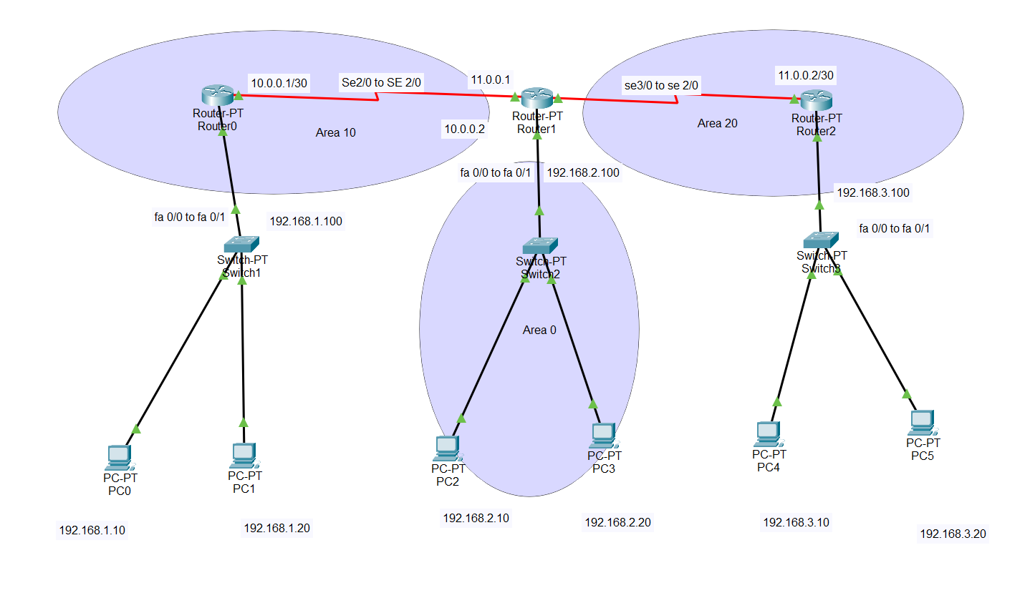

* **Configuration of routers:**
  + **Router 0:**

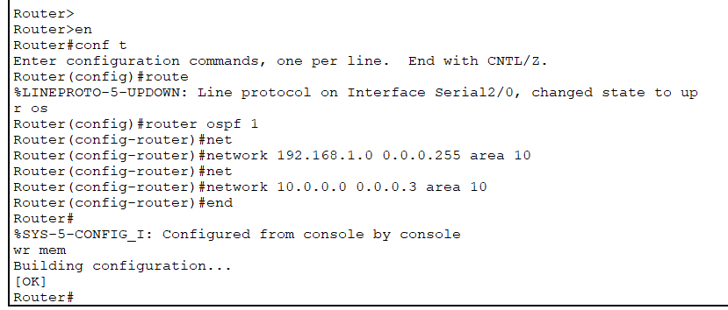

* + **Router 1:**

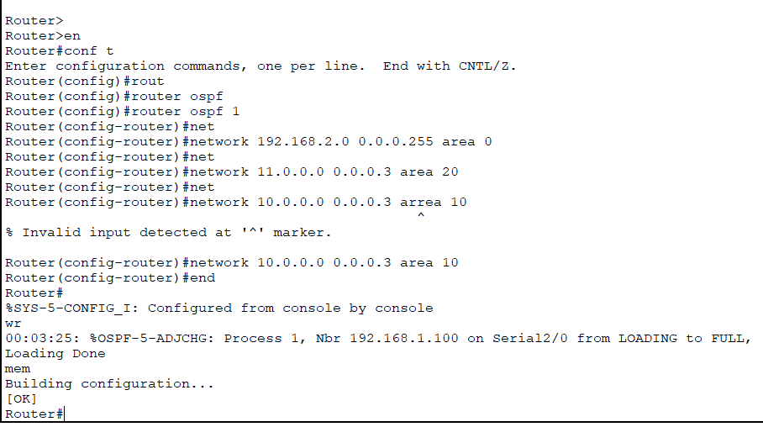

* + **Router 2:**

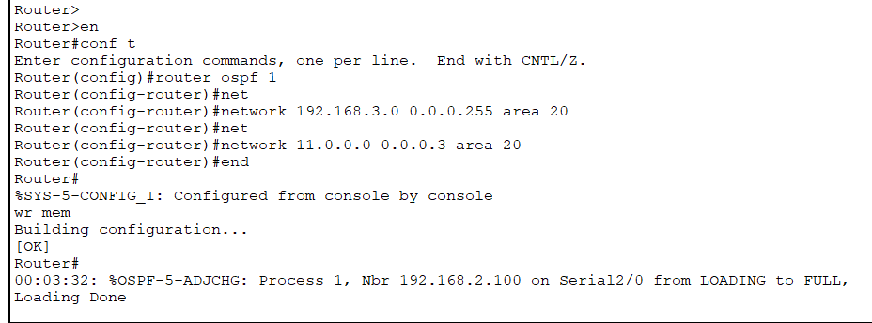

* **Interface configuration and route verifications:**
  + **Interface brief:**
    - **Router 0:**

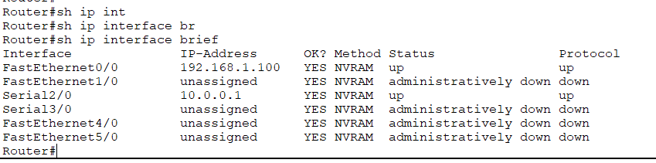

* + - **Router 1:**

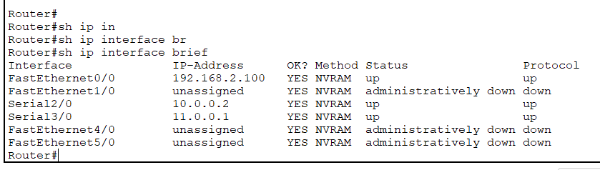

* + - **Router 2:**

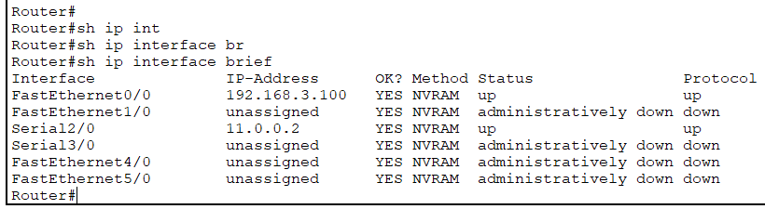

* + **Ip routes:**
    - **Router 0:**

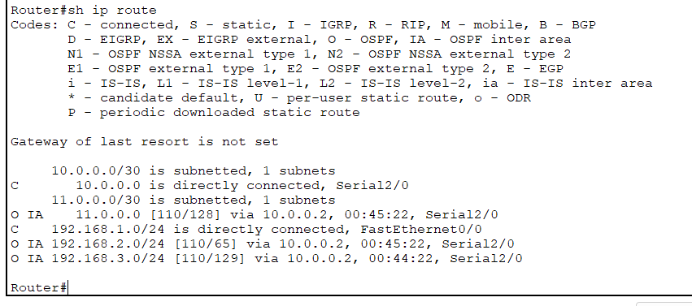

* + - **Router 1:**

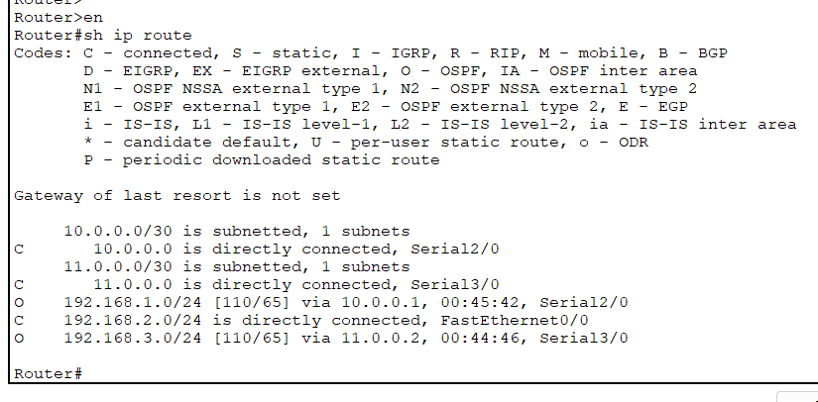

* + - **Router 2:**

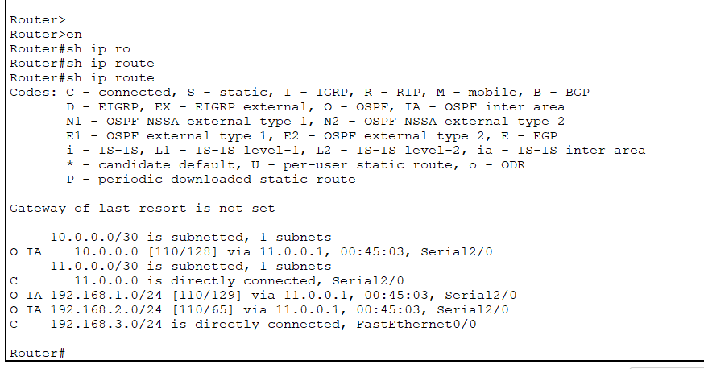

* + **Ip protocols:**
    - **Router 0:**

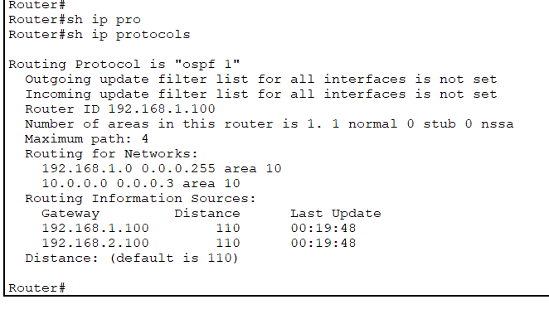

* + - **Router 1:**

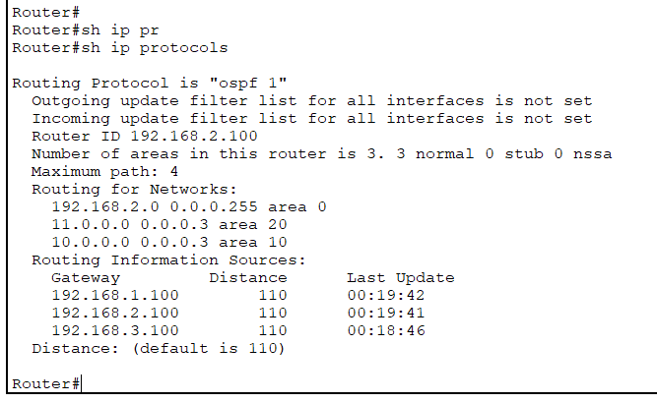

* + - **Router 2:**

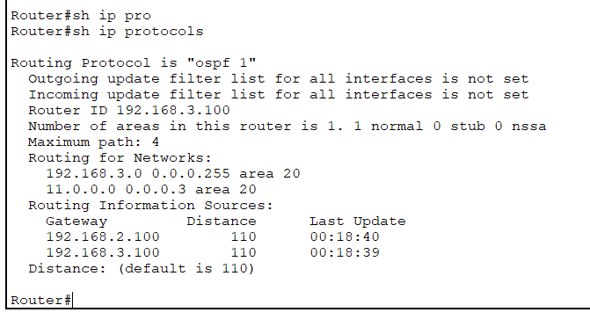

* + **OSPF database:**
    - **Router 0:**

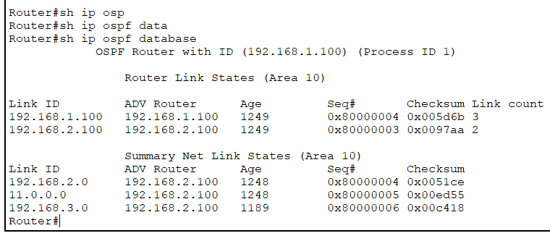

* + - **Router 2:**

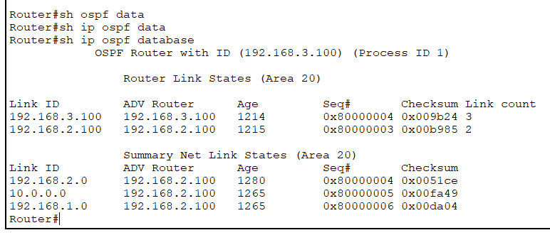

* + - **Router 1:**

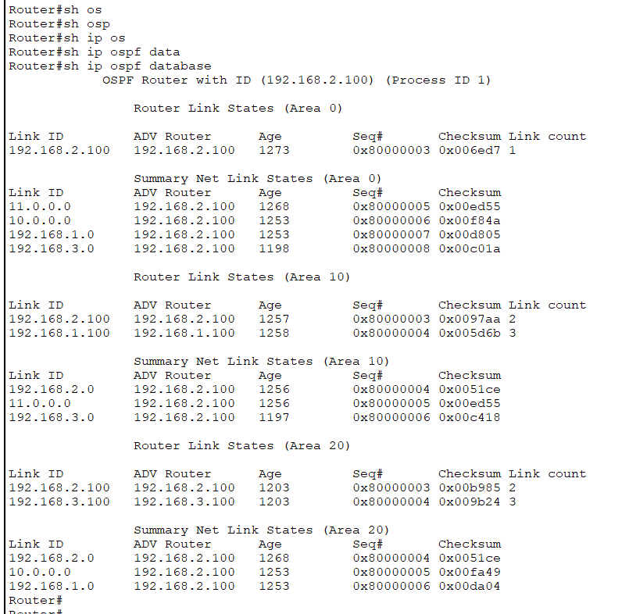

* **Pinging from Devices:**
  + **PC 0:**

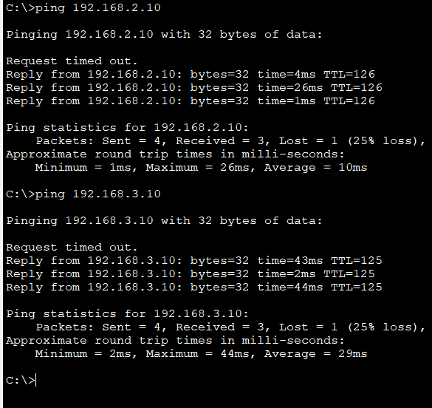

* + **PC 2:**

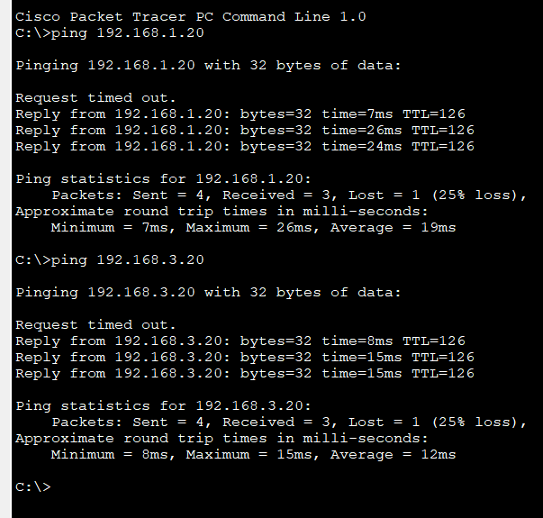

* + **PC 4:**

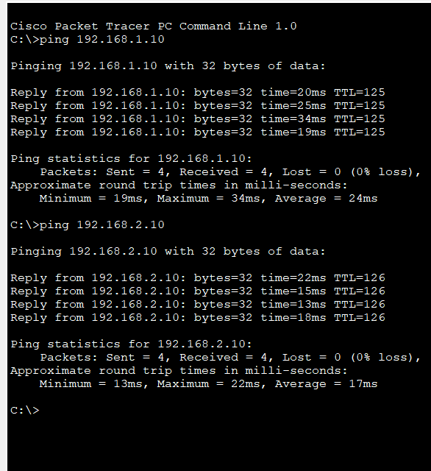

***Conclusion:***

Hence, the network was designed to implement and verify the features of Open Shortest Path First(OSPF) across multiple areas, which enabled communication between the virtual devices in the network communicate through dynamic routing by dividing the network in hierarchical manner based on the OSPF domain of the network.